Training Session – BOM, MR, and DP

Access to Bill of Material, Master Requirement, and Delivery Plan 3

Access from project 3

Access from Team Space 5

Create BOM Objects 6

BOM Creation from the Item Pop-up 6

BOM Creation from the Import 7

Bill of Material Form 9

Fields retrieve data from the ITEM Pop-up: 10

Fields retrieve data from the MR: 10

Fields to be filled manually: 10

Save/Apply BOM form 11

BOM widget options: 11

BOM Split: 11

Create MR Objects 13

MR Creation from the Item Pop-up 13

MR Creation from the Import 14

Master Requirement Form 16

Fields retrieve data from the ITEM Pop-up: 17

Fields to be filled manually: 17

Fields retrieve data from the BOM: 18

Progress % field: 18

Save/Apply MR form 19

MR widget options: 19

MR Split: 19

MR Progress % Calculation: 20

MF Progress Milestone 20

Roll Up Progress % 21

MR Warnings: 22

Create DP Objects 23

DP Creation from the MR 23

DP Creation from the Import 23

Delivery Plan Form 25

Fields retrieve data from the MR: 26

Fields to be filled manually: 27

Fields retrieve data automatically: 28

Save/Apply MR form 28

Field Logics of DP Form: 29

DP widget options: 29

DP Split: 30

Views of DP Widget: 30

Summary View 31

Extended View 31

DP Warnings: 32

# Access to Bill of Material, Master Requirement, and Delivery Plan

## Icon Description automatically generatedAccess from project

Within the Home Page by clicking on the icon you can access the Application Menu.

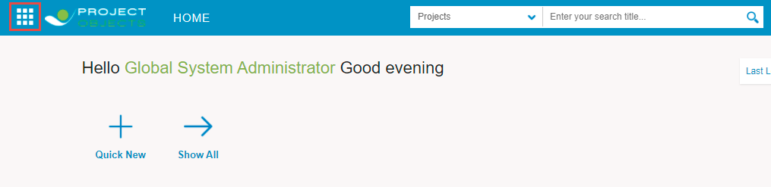

Mouse over the Projects Icon and click on Projects, as shown in the image below.

This will give you access to all relevant projects you are working on.

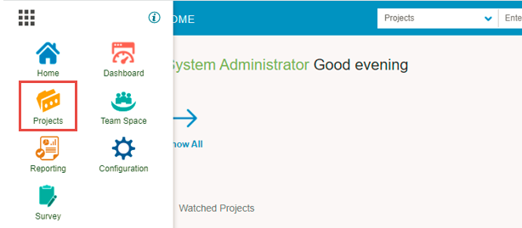

To access the Workspace, click on the project name and then to the icon  or simply right-click on the project name:

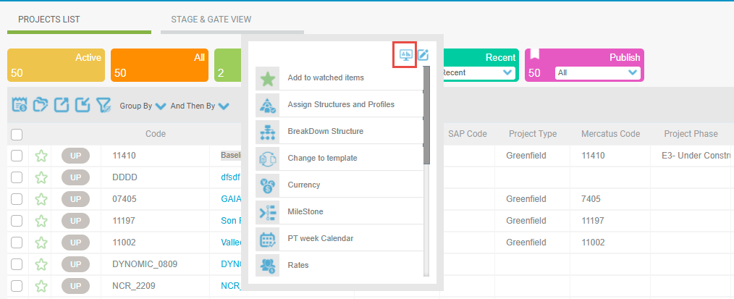

When you have opened the Project Details page, you can then also click on the tab called "Workspace" to directly proceed to the workspace:

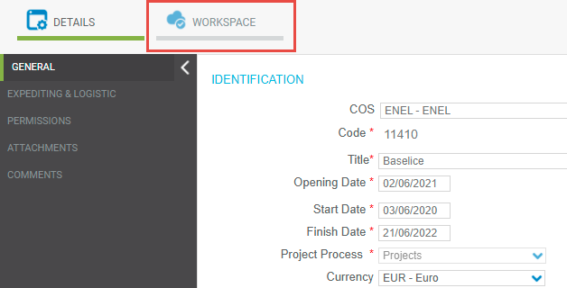

Select the "BOM" or “MR” or “DP” tab.

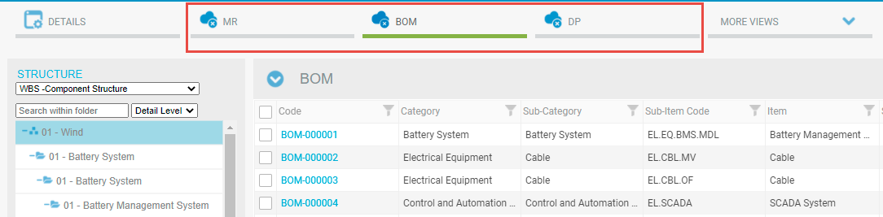

If the "BOM, MR, DP" tabs are not visible, click on the TAB selector to add it to those shown.

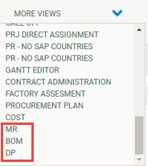

Here you can visualize the BOM, MR, and DP related to the selected project.



## Access from Team Space

The Team Space module can be opened from the homepage Application Menu.

From the Team Space menu, select the “BOM, MR, and DP” process.

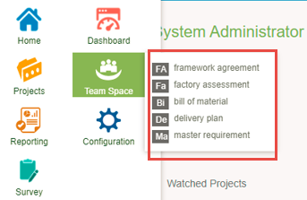

Here you can visualize the list of all BOM, MR, and DP in PO and group/filter them with the appropriate parameters.

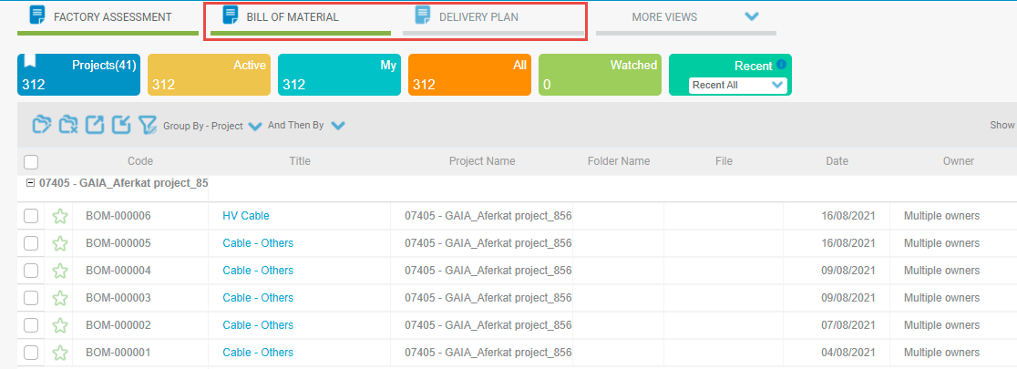

# Create BOM Objects

## BOM Creation from the Item Pop-up

Users can create BOM objects from the ITEM pop-up. A menu option associate item is available at the left tree structure and visible only in the root node **Overall**.

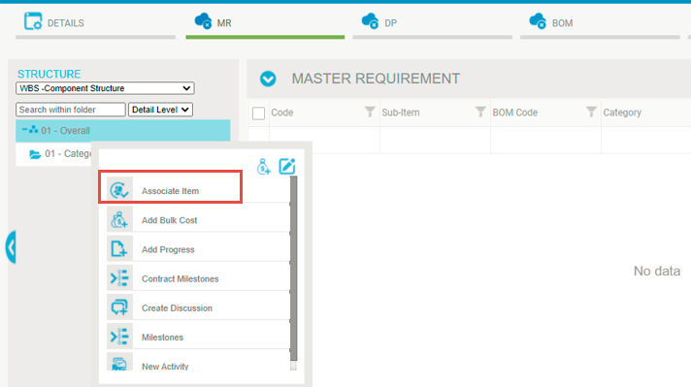

When a user clicks on the Associate Item icon, an ITEM pop-up will be open with details of Item, Sub-Items, etc. From here user can select items and click on the save icon.

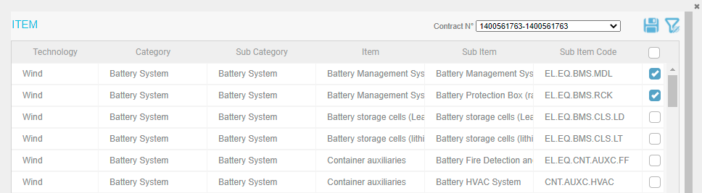

On performing save operation BOM objects will be created and visible in the BOM grid in the project workspace.

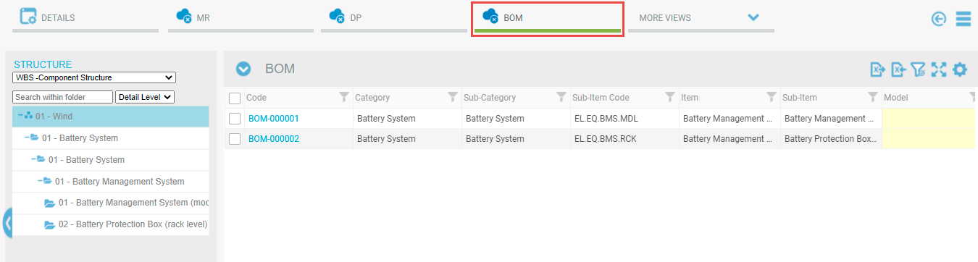

On the creation of BOM, MR objects are also created automatically. Users can see the MR objects in the MR grid of the project workspace.

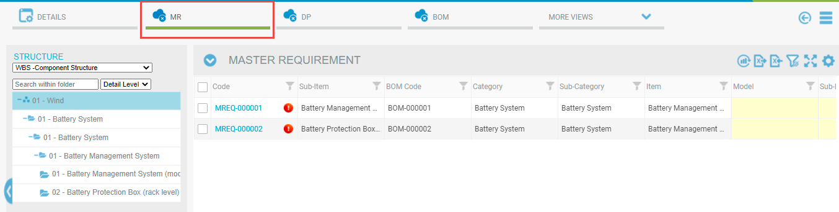

## BOM Creation from the Import

Users can create BOM Objects from the Import function. For importing BOM objects user needs to export the BOM excel template from the icon given at the top of the BOM grid.

Here users can download 2 types of templates: with data or without data.

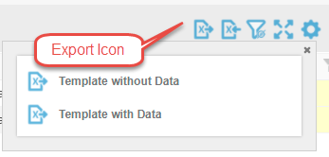

A downloaded template will be visible like this and the user will enter the data in the download template and save the file with data.

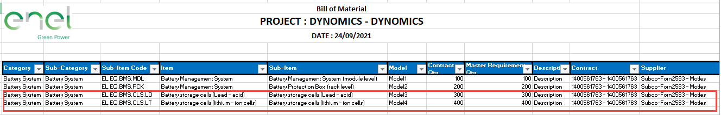

Now users need to import this data using the import icon given on the top of the grid.

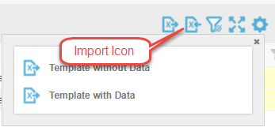

When a user clicks on the import icon, then an import pop-up will be open. The user needs to select the BOM file and then needs to click on the import icon.

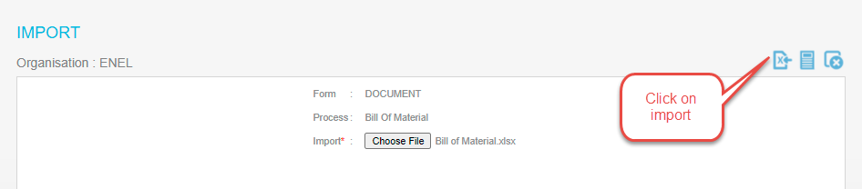

When the import process will be completed “Data Imported Successfully” message will appears

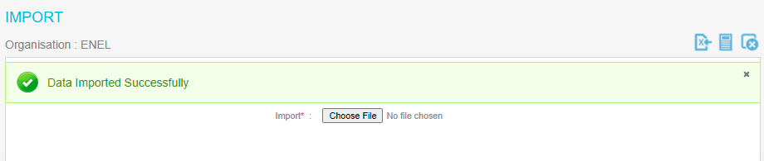

And imported objects will be visible in the BOM grid.

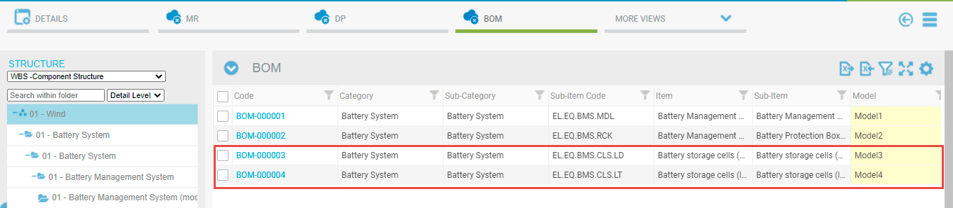

Users can see the import history in the import log. To see the import history user needs to click on the log icon of the import pop-up.

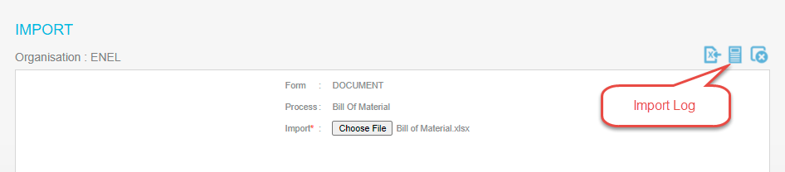

With on click of this icon, the import log will be visible with some columns showing the import history. Here import log will always show the last imported data.

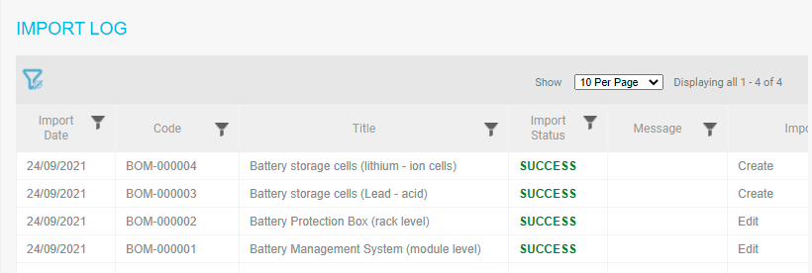

# Bill of Material Form

The BOM form contains only one tab: General. With on click of the BOM code, the BOM form will be open.

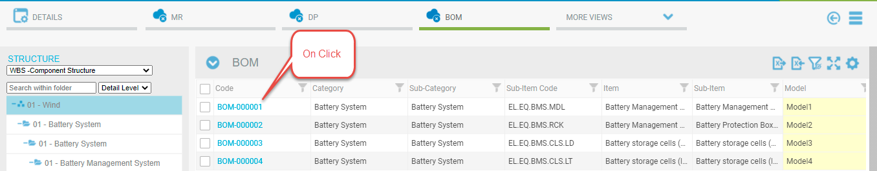

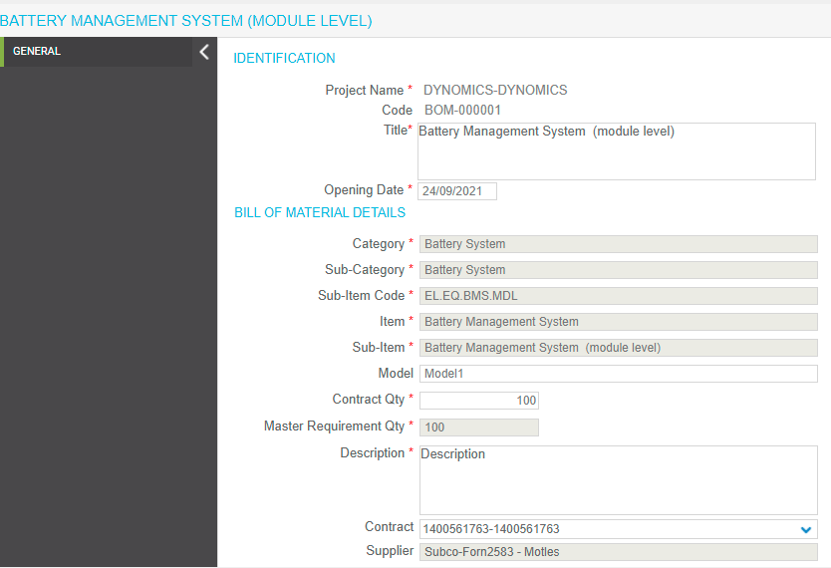

In the following paragraphs, BOM form details are provided:

## Fields retrieve data from the ITEM Pop-up:

Category, Sub-Category, Sub-Item Code, Item, and Sub-Item data will be retrieved from the Item pop-up and filled automatically at the time of BOM creation.

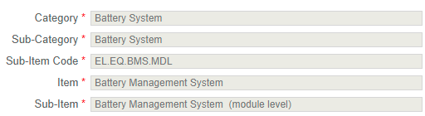

## Fields retrieve data from the MR:

Master Requirement Qty field will retrieve data from the Contract QTY Forecast/Actual field of MR form.



## Fields to be filled manually:

Model, Contract Qty, Description, and Contract fields are filled manually.

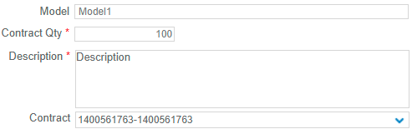

**Fields Automatically retrieved on the selection of Contract:**

On selection of Contract in BOM form, Supplier will be updated automatically.



|  |  |
| --- | --- |
|  | Note that for any field, if you see a red star in front of it, it means the field requires to be filled in |

## Save/Apply BOM form

  button, in the upper-right corner of the form, your object will be added to the grid.

Clicking on the Save icon will Save and Close your object while clicking on the "Apply" icon will Save your object, but it remains open.

# BOM widget options:

There are various options available on the Widget of BOM which is used to perform the following operations:

 - this is used to save data in the BOM grid.

 - this is used to delete selected objects from the BOM grid.

- this is used to clear applied filters from the BOM grid.

- this is used to zoom-in BOM grid.

- this is used to undo the changes of the BOM grid.

C:\Users\VIVEK\AppData\Local\Temp\SNAGHTMLaa0f37.PNG- this is used to select or deselect columns on the BOM grid.

# BOM Split:

Users can split the BOM objects based on Contract Qty. The “Split Selected BOM Line” option is available in the context menu of BOM objects.

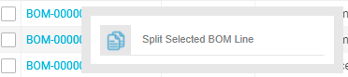

When the user clicks on the “Split Selected BOM Line” and enters the Qty in the field. On click of save icon selected BOM line will get split.

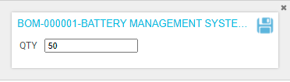

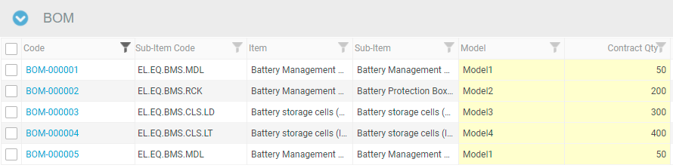

# Create MR Objects

## MR Creation from the Item Pop-up

Similar to BOM objects, users can also create MR objects from the ITEM pop-up. A menu option associate item is available at the left tree structure and visible only in the root node **Overall**.



When a user clicks on the Associate Item icon, an ITEM pop-up will be open with details of Item, Sub-Items, etc. From here user can select items and click on the save icon.



On performing save operation MR objects will be created and visible in the MR grid in the project workspace.



On the creation of MR, BOM objects are also created automatically. Users can see the BOM objects in the BOM grid of the project workspace.



## MR Creation from the Import

Users can create MR Objects from the Import function. For importing MR objects user needs to export the MR excel template from the icon given at the top of the MR grid.

Here users can download 2 types of templates: with data or without data.



A downloaded template will be visible like this and the user will enter the data in the download template and save the file with data.

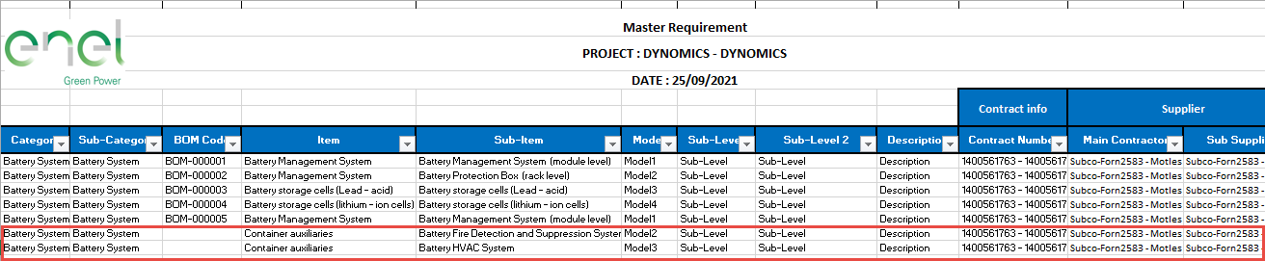

Now users need to import this data using the import icon given on the top of the grid.



When a user clicks on the import icon, then an import pop-up will be open. The user needs to select the MR file and then needs to click on the import icon.

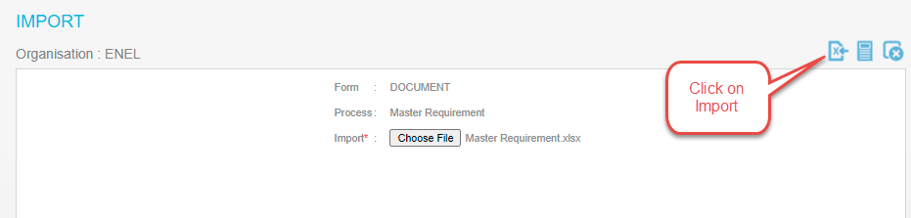

When the import process will be completed “Data Imported Successfully” message will appears



And imported objects will be visible in the MR grid.

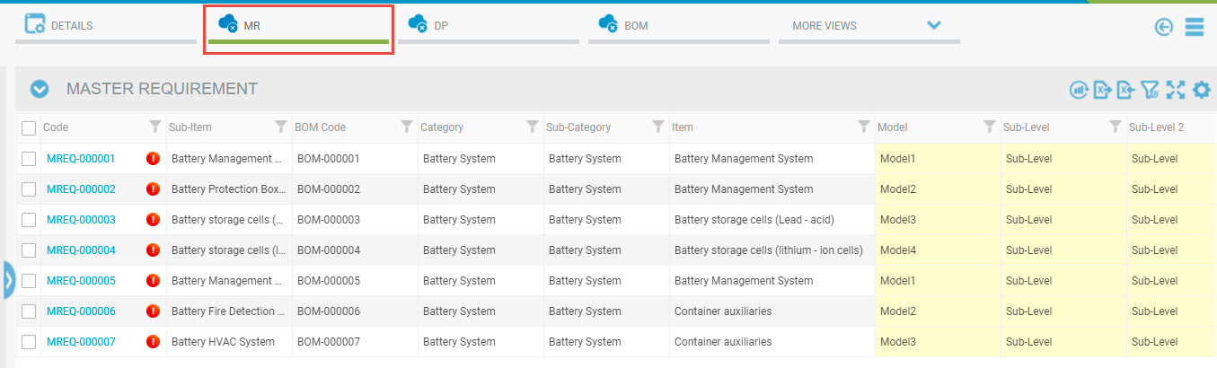

Users can see the import history in the import log. To see the import history user needs to click on the log icon of the import pop-up.

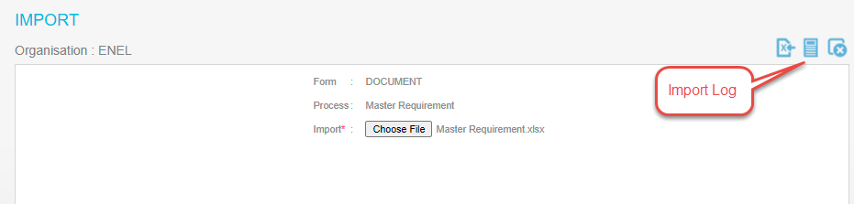

With on click of this icon, the import log will be visible with some columns showing the import history. Here import log will always show the last imported data.

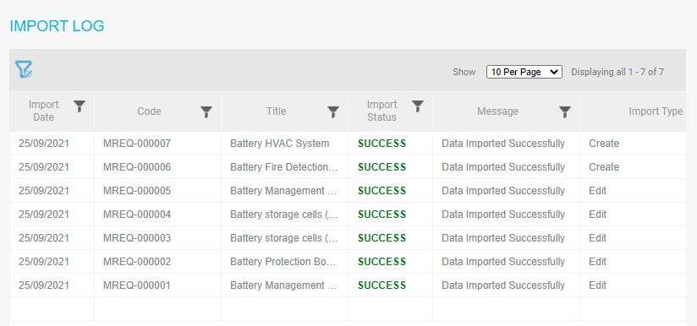

# Master Requirement Form

The MR form contains only one tab: General. With one click of the MR code, the MR form will be open.

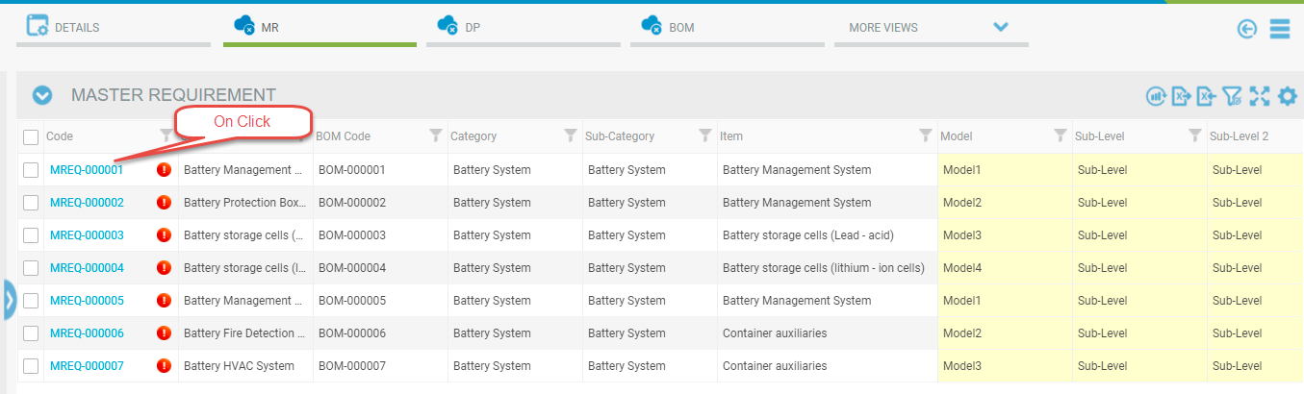

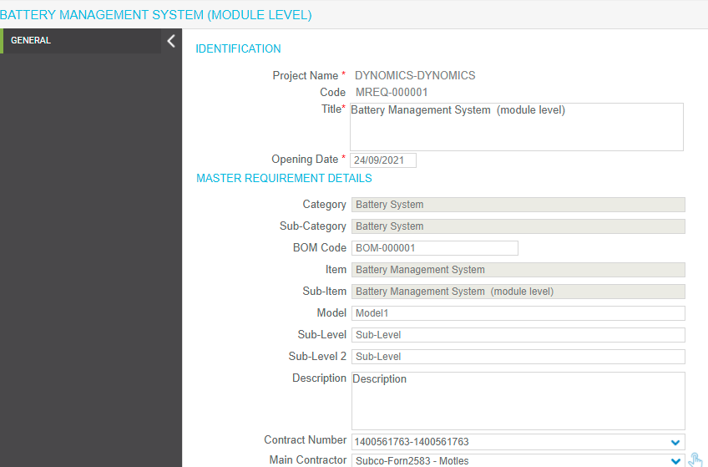

In the following paragraphs, MR form details are provided:

## Fields retrieve data from the ITEM Pop-up:

Category, Sub-Category, Item, and Sub-Item data will be retrieved from the Item pop-up and filled automatically at the time of MR creation.

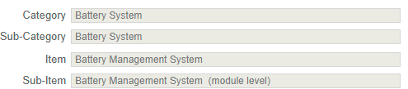

## Fields to be filled manually:

Sub Level, Sub Level 2, Description, Contract Qty Forecast/Actual, Man.Start Contract Date, Man.Start Forecast/Actual, Man.FAT Contrat Date, Man.FAT Forecast/Actual, Man.Final/Pre-Ship Insp. Cont. Date, Man.Final/Pre-Ship Insp. Forecast/Actual, Note fields are filled manually.

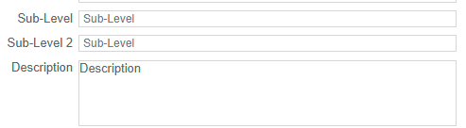



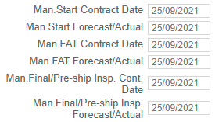

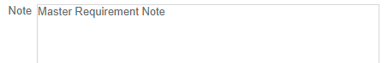

**Fields Automatically retrieved On Contract selection:**

On selection of Contract in MR form, Main Contractor, Sub-Supplier, Factory, Location, Contract Order Date Forecast/Actual will be updated automatically.

Main Contractor, Sub-Supplier, and Contract Order Date Forecast/Actual will be retrieved from the Contract, Factory, and Location data will be retrieved from the factory associated with the Sub-Supplier.

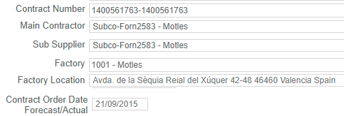

## Fields retrieve data from the BOM:

BOM Code and Model field will retrieve data from the interconnected BOM objects.

C:\Users\VIVEK\AppData\Local\Temp\SNAGHTML2d7a018.PNG

## Progress % field:

Progress % can be calculated automatically or the user can also enter data in the Progress % field manually.





|  |  |
| --- | --- |
|  | Note that for any field, if you see a red star in front of it, it means the field requires to be filled in |

## Save/Apply MR form

  button, in the upper-right corner of the form, your object will be added to the grid.

Clicking on the Save icon will Save and Close your object while clicking on the "Apply" icon will Save your object, but it remains open.

# MR widget options:

There are various options available on the Widget of MR which is used to perform the following operations:

 - this is used to save data in the MR grid.

 - this is used to delete selected objects from the MR grid.

- this is used to clear applied filters from the MR grid.

- this is used to zoom in the MR grid.

- this is used to undo the changes of the MR grid.

C:\Users\VIVEK\AppData\Local\Temp\SNAGHTMLaa0f37.PNG- this is used to select or deselect columns on the MR grid.

 - this is used to update the progress % on-demand.

# MR Split:

Users can split the MR objects based on Contract Number, Supplier, Sub-Supplier, and Qty. The “Split Selected MR Line” option is available in the context menu of MR objects.

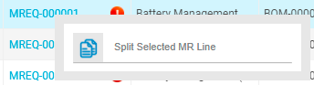

When the user clicks on the “Split Selected MR Line” and enters the Qty in the field. On click of save icon selected MR line will get split.

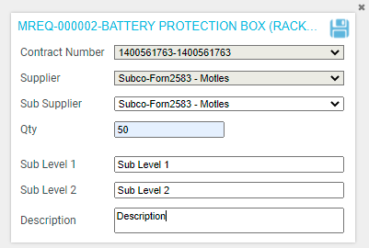

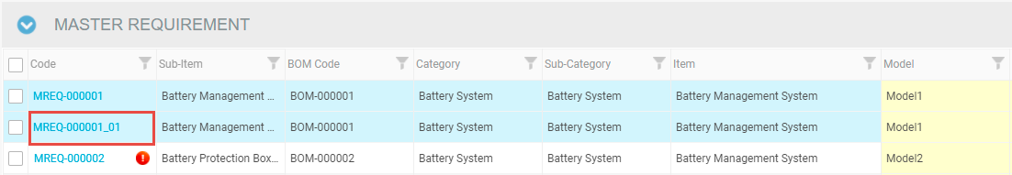

# MR Progress % Calculation:

## MF Progress Milestone

We have created a master page for the MF Progress Milestone. Users can find this page under the General tab of the Standard Code Page.

Company Setting > Standard Codes > General Tab> MF Progress Milestone

Here we have defined the settings for the calculation of Progress % of MR objects. Here we have 4 date fields and for each date, fields progress % is defined. Users can also change the progress % according to requirements.

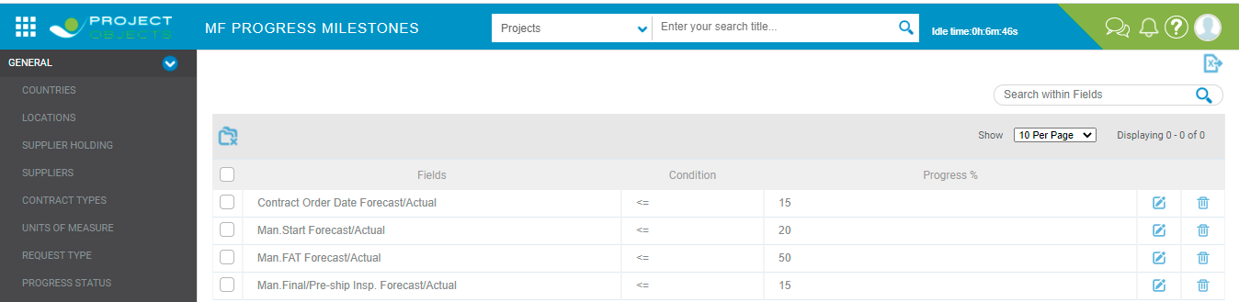

Dates entered in these 4 fields of MR objects are compared with today’s date and if the entered date is <= today’s date, then progress % in MR objects is updated accordingly.

For example, if Contract Order Date Forecast/Actual <= Today’s date then Progress % will be updated as 15 % in MR objects.

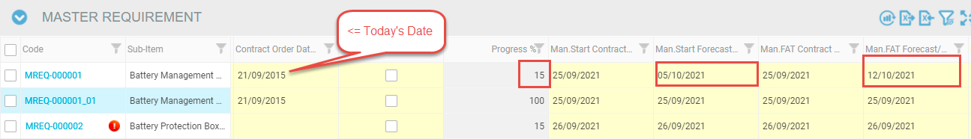

Similarly, if conditions are satisfied with the other date fields, the percent will be added with the current progress %.

Users can also enter percent manually by checking the Manual Progress check box. In this case, automatic progress % percent will not work and the user can enter progress % manually.

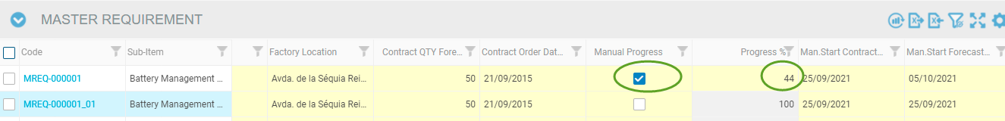

## Roll Up Progress %

If an MR object is split more than 1 time .i.e an MR object is being split 2 times, then the progress percent of parent objects will be the average of progress % of its child. Users can also change the progress percent of parents manually or automatically.

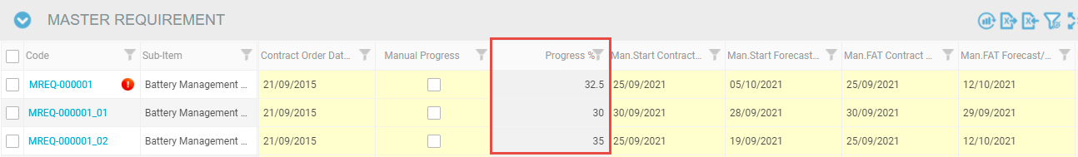

If the progress % of any MR objects is 100 % then that row will be highlighted with the Blue color.

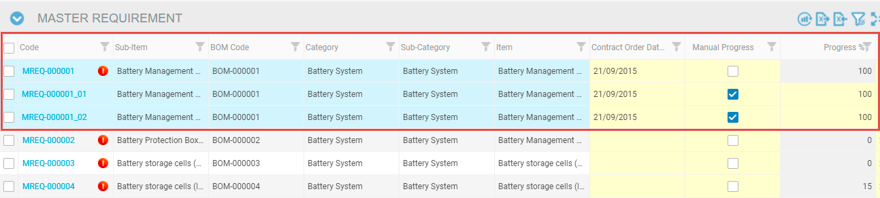

# MR Warnings:

If there are some inconsistencies between the interconnected BOM and MR objects, then waring icon  will be visible adjacent to the MR Code and on hovering the warning icon, a warning message will appear.

There will following types of inconsistencies:

1. Contract Number
2. Supplier
3. Contract QTY
4. MR Dates

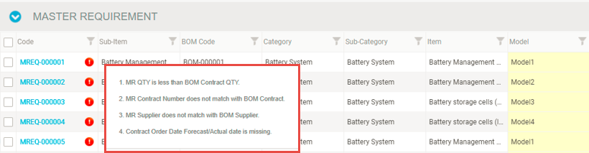

A similar warning will also appear when we save the MR form from the edit pop-up:

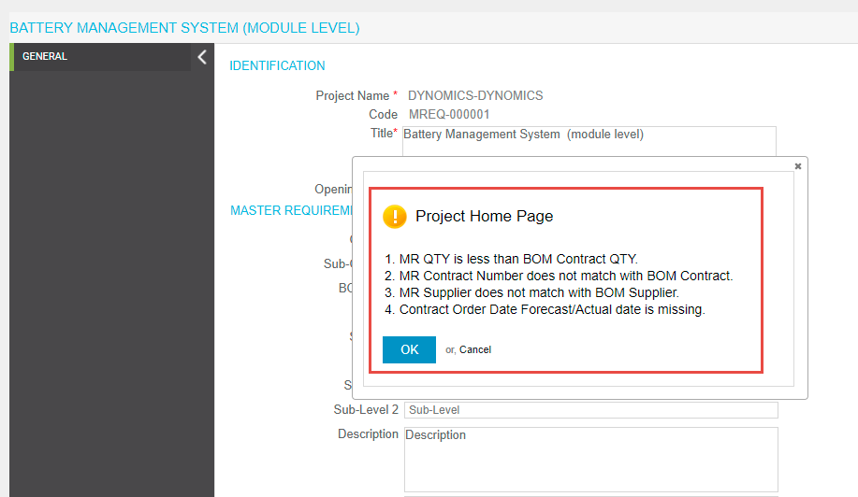

# Create DP Objects

## DP Creation from the MR

Users can create Delivery Plan objects from the Master Requirement. For this user needs to click on the icon  given at the top of the DP widget. On clicking, this icon DP objects will be created from the MR and visible in the DP grid. For each MR object, there will be an interconnected DP object.

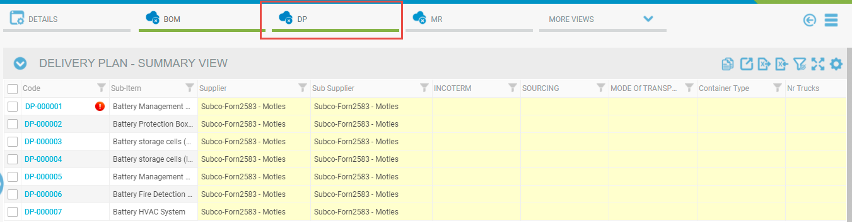

## DP Creation from the Import

Users can create DP Objects from the Import function. For importing DP objects user needs to export the DP excel template from the icon given at the top of the DP grid.

Here users can download 2 types of templates: with data or without data.



A downloaded template will be visible like this and the user will enter the data in the download template and save the file with data.

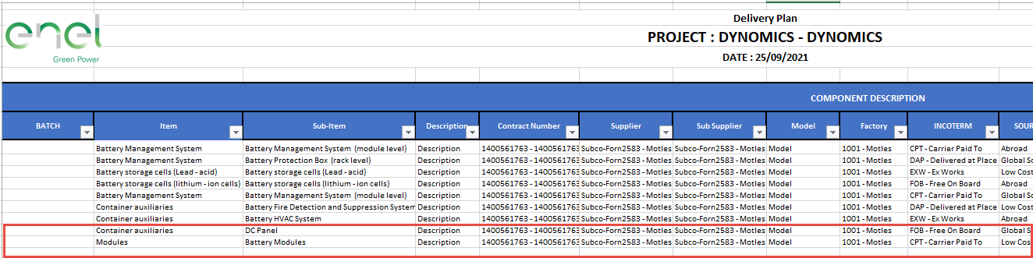

Now users need to import this data using the import icon given on the top of the grid.



When a user clicks on the import icon, then an import pop-up will be open. The user needs to select the DP file and then needs to click on the import icon.

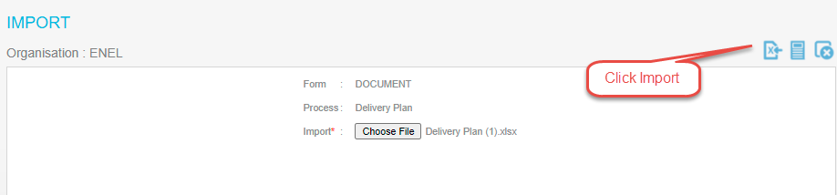

When the import process will be completed “Data Imported Successfully” message will appears



And imported objects will be visible in the DP grid.

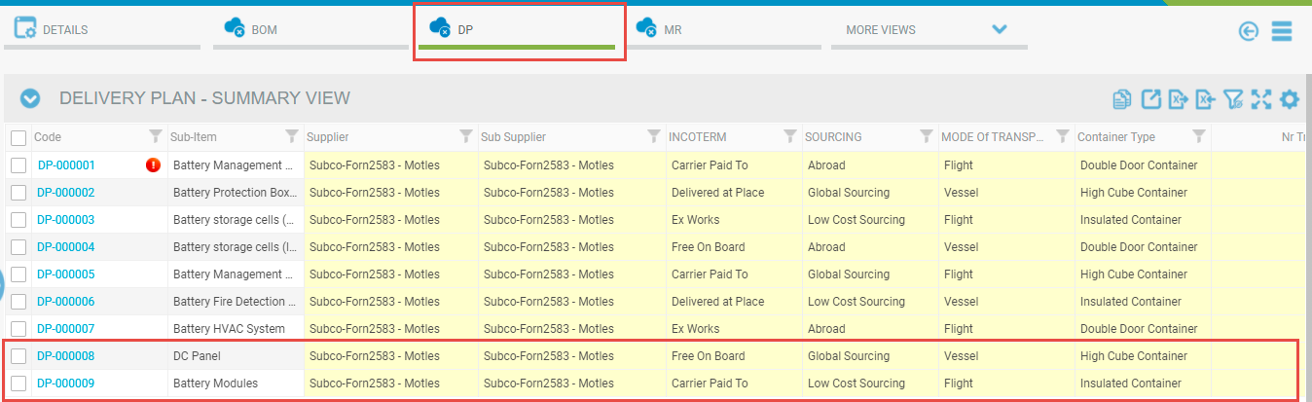

Users can see the import history in the import log. To see the import history user needs to click on the log icon of the import pop-up.

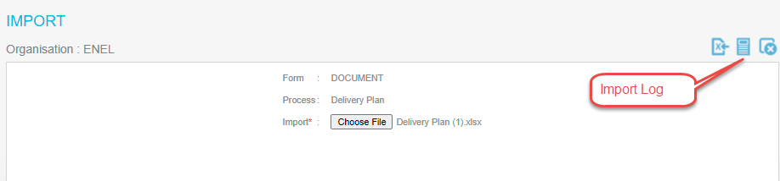

With on click of this icon, the import log will be visible with some columns showing the import history. Here import log will always show the last imported data.

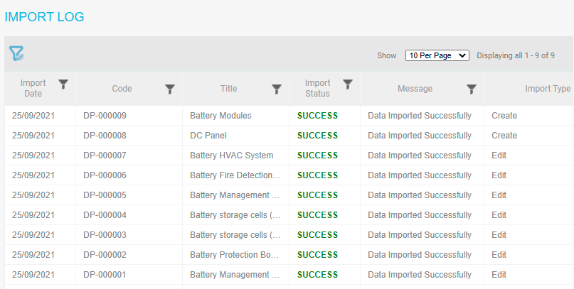

# Delivery Plan Form

The DP form contains only one tab: General. With one click of the DP code, the DP form will be open.

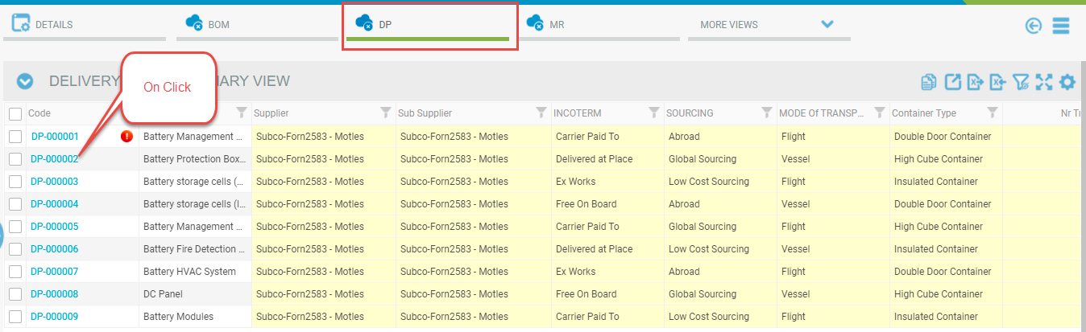

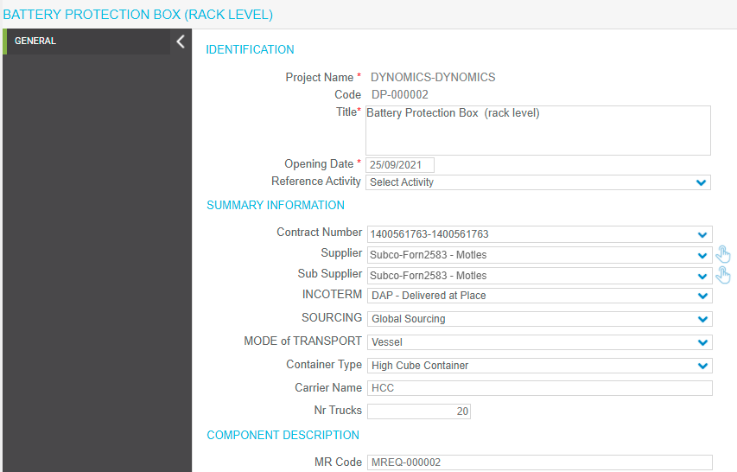

In the following paragraphs, DP form details are provided:

## Fields retrieve data from the MR:

Contract Number, Supplier, Sub-Supplier, MR Code, Item, Sub-Item, Factory, QTY, EXW data will be retrieved from the interconnected MR objects and filled automatically at the time of DP creation.

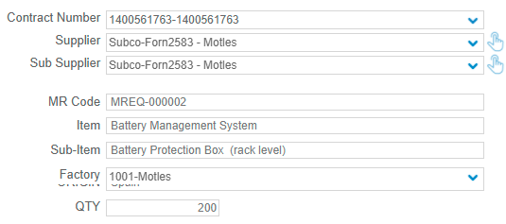

EXW field retrieves data from the Man.Final/Pre-Ship Insp. Forecast/Actual field of MR objects.



## Fields to be filled manually:

Incoterm, Sourcing, Mode of Transport, Container Type, Carrier Name, Nr. Trucks, Description, Model, Unit of Measure, Qty Container, ETD, ETA, Custom Clearance, DOS Baseline Start, DOS Baseline Finish, DOS Act/For Start. DOS Act/For Finish, Container N/Serial N, Gross Weight, BL/AWB/PL, Vessel Name/Flight Number, Port of Loading, Port of Discharge, Note, DOS Project Need fields are filled manually.

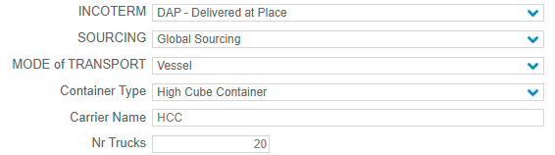

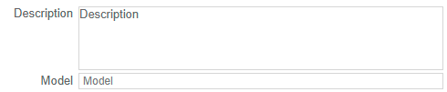



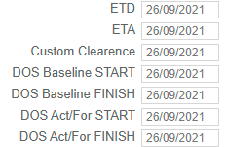

Data in the fields Vessel Name, Port of Loading, Port of Discharge is bonded from the Port and Vessel data of Standard Codes.

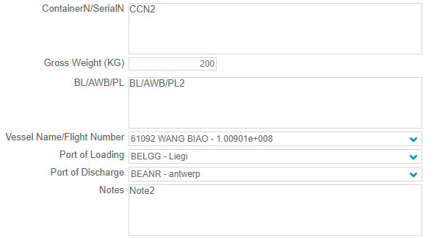

**Fields Automatically retrieved On Contract selection:**

On selection of Contract in DR form, Main Supplier and Sub-Supplier data are retrieved.

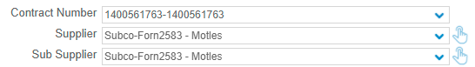

Factory and Origin data will be retrieved from the factory associated with the Sub-Supplier.



## Fields retrieve data automatically:

Data in the fields BATCH and Planning Code fields is retrieved automatically from the following fields:

1. Batch – When DP objects are getting Split then the Batch Number is updated automatically in the field. For example, we made 3 batches by split then Batch Number will be 1 for parent and 2,3 and respectively for the child.



1. Planning Code – Data will be retrieved in this field from the Expediting PCode column of the ITEM library.



|  |  |
| --- | --- |
|  | Note that for any field, if you see a red star in front of it, it means the field requires to be filled in |

## Save/Apply MR form

  button, in the upper-right corner of the form, your object will be added to the grid.

Clicking on the Save icon will Save and Close your object while clicking on the "Apply" icon will Save your object, but it remains open.

# Field Logics of DP Form:

Here in the delivery plan form, we have implemented the logic of the following field:

1. If SOURCING =” LOCAL”, then: VESSEL NAME/FLIGHT NUMBER; PORT OF LOADING; PORT OF DISCHARGE; ETD; ETA; CUSTOM CLEARANCE must be set=NULL and disabled.

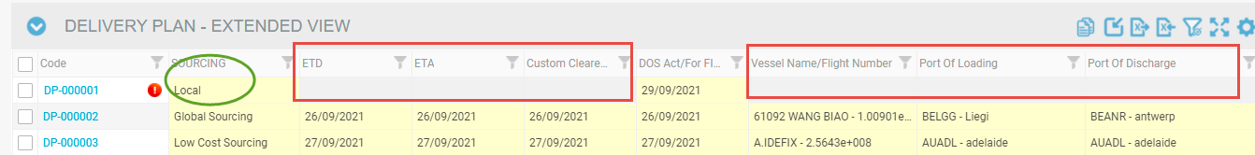

1. If CONTAINER TYPE= "NA", then: QTY CONTAINERS must be set=NULL and disabled.

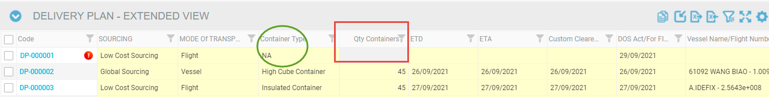

1. If MODE OF TRANSPORT <> "VESSEL" OR "FLIGHT", then: VESSEL NAME/FLIGHT NUMBER; PORT OF LOADING; PORT OF DISCHARGE; ETD; ETA must be set=NULL and disabled.

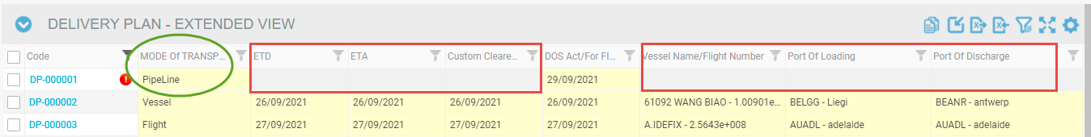

# DP widget options:

There are various options available on the Widget of DP which is used to perform the following operations:

 - this is used to save data in the DP grid.

 - this is used to delete selected objects from the DP grid.

- this is used to clear applied filters from the DP grid.

- this is used to zoom-in DP grid.

- this is used to undo the changes of the DP grid.

C:\Users\VIVEK\AppData\Local\Temp\SNAGHTMLaa0f37.PNG- this is used to select or deselect columns on the DP grid.

- this is used to switch between Summary View and Extended view.

# DP Split:

Users can split the DP objects based on Number of Batches he wants to make after the split. The “Split Selected DP Line” option is available in the context menu of DP objects.

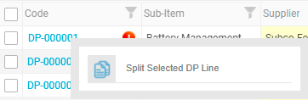

When the user clicks on the “Split Selected DP Line” and enters the Number of Batch in the field. On click of save icon selected DP line will get split into the batches.

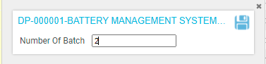

Here DP will be split into 3 batches. 1 is for the parent and 2, 3 is for the child.

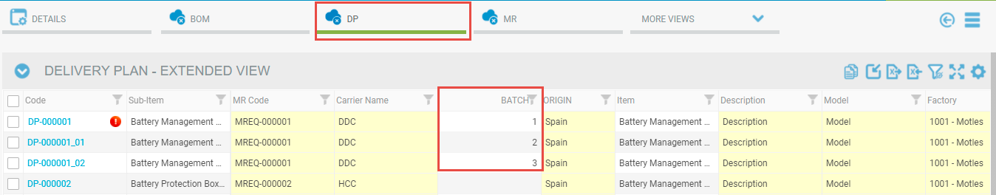

# Views of DP Widget:

Here we have 2 views of the Delivery Plan Widget: User can switch to any view as per his choice.

1. Summary View.
2. Extended View

## Summary View

In the Summary view, we have only 10 columns available in the widget and users can see a maximum of only these 10 columns.

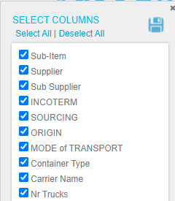

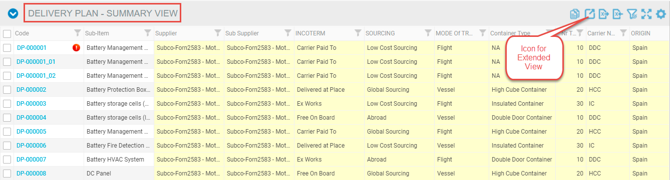

When a user clicks on the icon Extended View, the DP widget will be switched to Extended View.

## Extended View

In Extended View we have all the columns available in the widget and users can see all the delivery plan columns here in the Extended View.

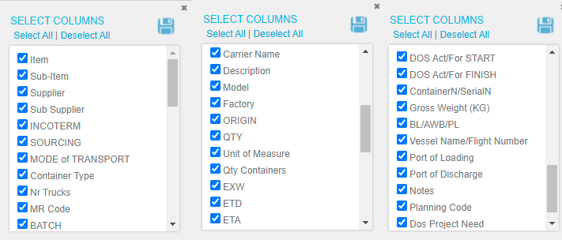

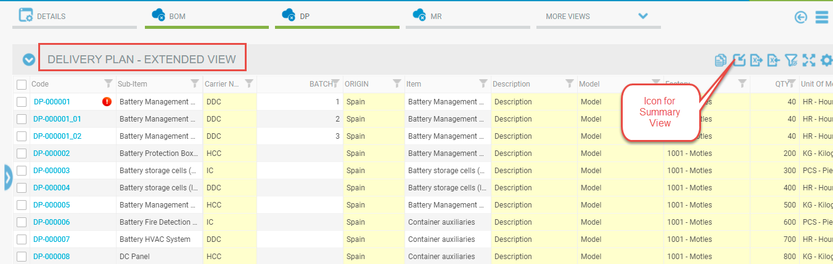

When a user clicks on the icon Summary View, the DP widget will be switched to Summary View.

# DP Warnings:

If there are some inconsistencies between the interconnected DP and MR objects, then waring icon  will be visible adjacent to the DP Code and on hovering the warning icon, a warning message will appear.

There will following types of inconsistencies:

Contract Number

Supplier

Factory

Contract QTY

EXW

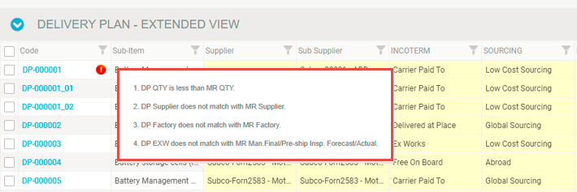

A similar warning will also appear when we save the MR form from the edit pop-up:

